* Product 7.155.318 – Diversey alcohol hand gel 70% - 500ml zonder pompje
  + ​

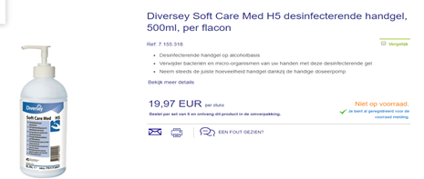

* Product 12 826 436 : Pollet alcohol hand gel 81% - 500 ml - NO pump system​​​​​​​
  + - Tariff price will be fixed at 9,95€

[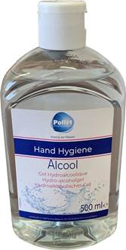](https://eu-prod.asyncgw.teams.microsoft.com/v1/objects/0-weu-d2-e98b86e51f026a9ac5c259b044531633/views/imgo)

* ​​​​​​​​​​​​​​​​​​​​​​​​​​​​​​​​​​​ Product : 12.819.955 : ecologische oppervlaktereiniger
  + Greenspeed Lacto Des disinfectant spray for surfaces - 500 ml
  + <https://www.greenspeed.eu/article_details.asp?section=05%2E02%2E03&article=4002900>
  + Tariff price will be fixed at 7,75€